**LAB # 04**

**Series R, L, C Circuits**



SUBMITTED BY: **Awais Saddiqui**

REG NO: **21PWCSE1993**

SECTION: **“A”**

SUMITTED TO: **Engineer Faiz Ullah Sir**

**UNIVERSITY OF ENGINEERING AND TECHNOLOGY PESHAWAR**

**COMPUTER SYSTEM ENGINEERING**

**ASSESSMENT RUBRICS**

|  |  |  |  |  |  |
| --- | --- | --- | --- | --- | --- |
|  | LAB REPORT ASSESSMENT | | | | |
|  | Criteria | Excellent | Average | Nil | Marks Obtained |
| 1. | Objectives of Lab | All objectives of lab are properly covered [Marks 1] | Objectives of lab are partially covered [Marks 0.5] | Objectives of lab are  not shown  [Marks 0] |  |
| 2. | Procedure | All experimental steps are shown. [Marks 2] | Some of the experimental steps are shown.  [Marks 1] | Experimental steps  not shown [Marks 0] |  |
| 3. | Demonstration of Concepts | The student demonstrated a clear understanding of the assignment concepts  [Marks 2] | The student demonstrated a clear understanding of some of the assignment concepts [Marks 1] | The student failed to demonstrate a clear understanding of the assignment concepts  [Marks 0] |  |
| 4. | Experimental  Results | All experimental results are completely shown in  form of table [Marks 3] | Experimental results are partially shown and some of the observations are missing [Marks 1.5] | No experimental results are shown  [Marks 0] |  |
| 5. | conclusion | Conclusion of the lab is properly written  [Marks 2] | Conclusion of the lab is partially written  [Marks 1] | Conclusion of lab is not written [Marks 0] |  |
|  | Total Marks Obtained: __________    Instructor Signature: ______________________ | | | | |

**Series R, L, C Circuits**

**Objectives:**

* This exercise examines the voltage and current relationships in series R, L, C networks.
* Of particular importance is the phase of the various components.
* How Kirchhoff’s Voltage Law is extended for AC circuits.
* Both time domain and phasor plots of the voltages are generated.

**Theory Overview:**

Each element has a unique phase response: for resistors, the voltage is always in phase with the current, for capacitors the voltage always lags the current by 90 degrees, and for inductors the voltage always leads the current by 90 degrees. Consequently, a series combination of R, L, and C components will yield a complex impedance with a phase angle between +90 and -90 degrees. Due to the phase response, Kirchhoff’s Voltage Law must be computed using vector (phasor) sums rather than simply relying on the magnitudes. Indeed, all computations of this nature, such as a voltage divider, must be computed using vectors.

**Equipment**

1. AC Function Generator

2. Oscilloscope DMM

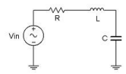

**Components**

1. Capacitor 10 nF

2. Inductor 10 mH

3. Resister 1 kΩ

**Procedure**

1. Using Figure 1 with Vin =2Vp-p sine at 10 kHz, R=1kΩ, L=10mH and C=10nF, determine the theoretical inductive and capacitive reactance and circuit impedance, and record the results in Table 1 (the experimental portion of this table will be filled out in step 4). Using the voltage divider rule, compute the resistor, inductor and capacitor voltages and record them in Table 2.
2. Build the circuit of Figure 1 using R=1kΩ, L=10mH and C=10nF. Set the generator to a 10 kHz sine wave and 2 Vp-p. Using oscilloscope measure the signals. Unfortunately, it is impossible to see the voltages of all the three components simultaneously using only two probes of the oscilloscope. To obtain the proper readings, place one probe on the function generator to see the input signal and the second probe across the last element. This step is repeated three times. The first time the components are so arranged that capacitor is the last component, the second time inductor is connected as the last component and finally resistor is made the last component. The peak-to peak voltages and phase angles of each one of the three components, relative to the source are thus determined in turn. Thus Vs, VC, VL and VR are measured. Record in Table 2.
3. Compute the deviations between the theoretical and experimental values of Table 2 and record the results in the final columns of this table.
4. Based on the experimental values, determine the experimental Z, XL and XC values via Ohm’s Law (i=VR/R, XL=VL/i, XC=VC/i, Z=Vin/i) and record back in Table 1 along with the deviations.
5. Create a phasor plot showing Vin, VL, VC, and VR.
6. Repeat the experiment for 1nF capacitor, 1mH inductor and 1kΩ resistor.

**Pictures:**

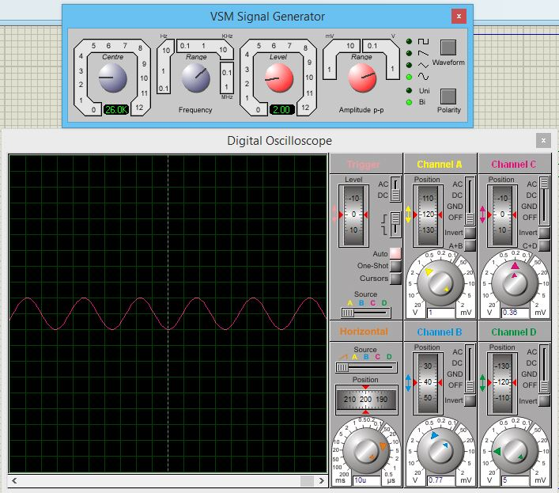

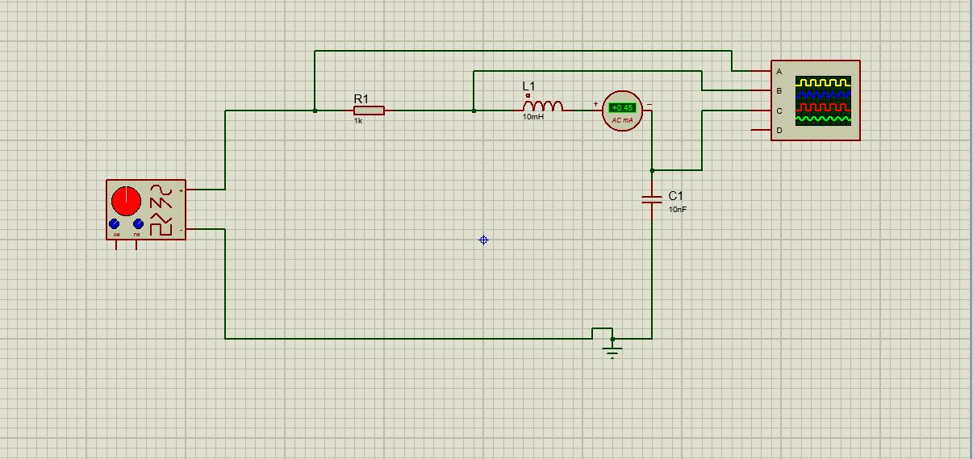

**Experimental results:**

**TABLE: 01**

|  |  |  |  |
| --- | --- | --- | --- |
|  | Theoretical | Experimental | %Deviation |
| XC | 1592 Ω | 1388 Ω | 1.8 % |
| XL | 628 Ω | 868 Ω | 3.2 % |
| Z | 1104 | 1388 | 5.7 % |
| Ɵ | -43.90 | -27.40 | 7.5 % |

**TABLE: 02**

|  |  |  |  |
| --- | --- | --- | --- |
|  | Theoretical | Experimental | %Deviation |
| VC | 2.29 V | 2 V | 2.66 % |
| VL | 0.90 V | 1.25 V | 8.8 % |
| VR | 2.88 V | 2 V | 3.5 % |
| VS | 2 V | 2 V | 0 % |
| Ɵ | -0.070 | -0.04O | 0.4 % |

**Questions**

1. **What is the phase relationship between R, L, and C components in a series AC circuit?**

**Answer:**

The phase relationship between R, L and C components in a series AC circuit depends upon the current lag or lead as the voltage across a pure resistor R, is in-phase with current. While the voltage across a pure inductor L, leads the current by 90 degrees. Moreover, the voltage across a pure capacitor C, lags the current by 90 degrees.

In conclusion, the relation between the three components is distinguished by the leading or lagging of current by certain degrees.

1. **Based on measurements, does Kirchhoff’s Voltage Law apply to the tested circuits?**

**Answer:**

We can use Kirchhoff’s voltage law for the purpose of analyzing series circuits. As the certain circuit is a closed loop and it obeys the law which is ΣV = 0.

1. **In general, how would the phasor diagram of Figure 1 change if the frequency was raised?**

**Answer:**

If the frequency of the voltage source is increased, then the magnitude of current would be impacted as it is directly proportional to impedance Z. Therefore, the value of impedance would have been higher.

1. **In general, how would the phasor diagram of Figure 1 change if the frequency was lowered?**

**Answer:**

If the frequency of the voltage source is decreased, then the magnitude of current would be impacted as it is directly proportional to impedance Z. Therefore, the value of impedance would have been lower.